Component | Image | Product Description | Source | Unit Price | Qty | Total Price | Notes
Case | 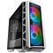 | Cooler Master MasterCase H500P Addressable RGB Mesh Mid Tower Case - White | PLE | $249.00 | 1 | $249.00 | case is white, but with rgb you can make it glow pink
Motherboard  Intel | 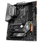 | MSI MAG Z390 TOMAHAWK LGA1151-CL ATX Desktop Motherboard | PLE | $309.00 | 1 | $309.00
GPU | 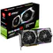 | MSI GeForce GTX1660 Super Gaming X 6GB GDDR6 | PLE | $509.00 | 1 | $509.00
Power  Supply | 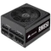 | Corsair RM850 850W 80Plus Gold Modular Power Supply | PLE | $249.00 | 1 | $249.00
CPU | 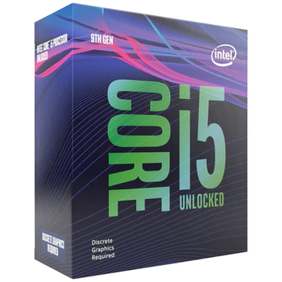 | Intel Core i5 9600KF 3.7Ghz Coffee Lake R 6 Core 6 Thread LGA1151-CL - No HSF/No iGPU Retail Box | PLE | $349.00 | 1 | $349.00
Memory | 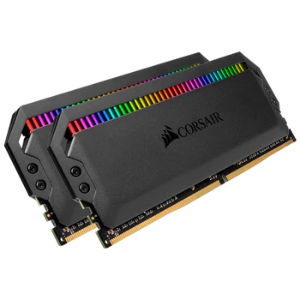 | Corsair 32GB Kit (2x16GB) DDR4 Vengeance RGB PRO 2666MHz C16 | PLE | $299.00 | 1 | $299.00 | rgb controlled by Corsair iCue
M.2 | 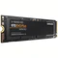 | Samsung 970 EVO Plus 1TB M.2 NVMe SSD | PLE | $359.00 | 1 | $359.00 | Game Drive
M.2 | 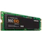 | Samsung 860 EVO Series 250GB M.2 SSD | PLE | $104.00 | 1 | $104.00 | System Drive  Use for operating system only
SSD |  | n/a |  |  |  | $0.00 | you have room to expand later up to 6 sata drives
HDD |  | n/a |  |  |  | $0.00 | you can add any high volume drive for mass media storage you like. Multi terabyte drives are cheap and easy to find now.
OS | 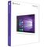 | Microsoft Windows 10 Professional OEM 64-Bit DVD |  | $235.00 | 1 | $235.00
CPU  Cooling |  | Corsair H100i RGB PRO XT AIO Liquid CPU Cooler |  | $219.00 | 1 | $219.00 | rgb controlled by Corsair iCue
Headset |  | pink headset | PLE | $219.00 | 1 | $219.00
 |  |  |  | $3,100.00 |  | $3,100.00
 |  |  |  |  |  | $3,100.00 | Build Cost:
 |  |  |  |  |  | $3,219.00 | Budget (AUS)
 |  |  |  |  |  | $119.00

